**Documentation**

Emailed links to Kanban flow because I couldn’t find a way to share through a link.

Mind map: <https://coggle.it/diagram/W63_nluwS8zoNatf/t/door-idea/184316b885e33a899eca84257bf51f3ecfe0d4acb8b6d1ee741e75322327a662>

User story map: <https://realtimeboard.com/welcomeonboard/1SstnuYdszwfFAEOIkSTxcy5aq97gtJixonuha1UNqqgw0sPFB1rNTxeiUQ8xiPP>

**Mood boards**

Mood board for the door scene

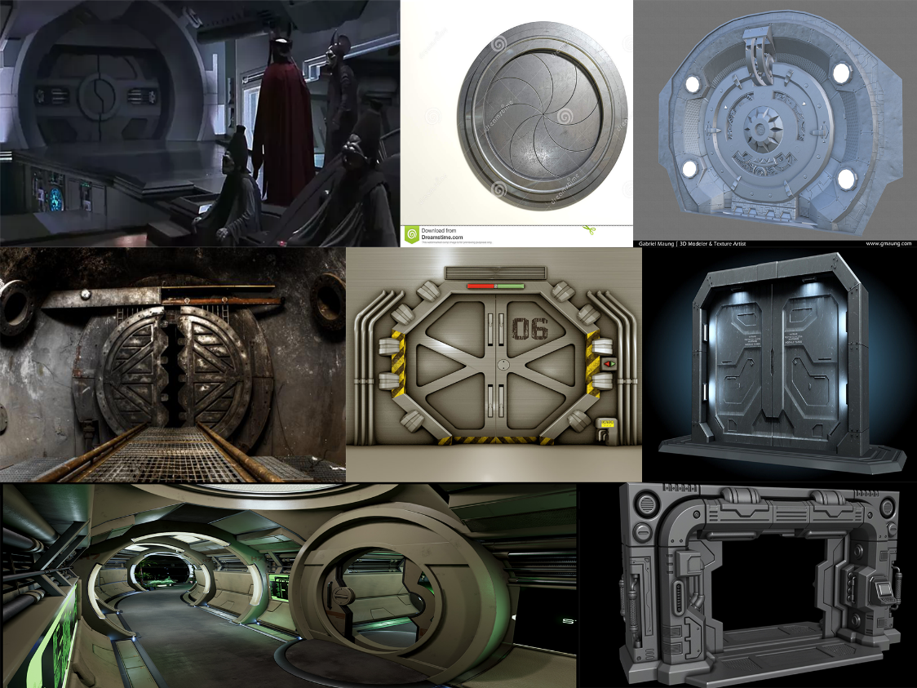

Mood board for kenji’s modern/simplistic room

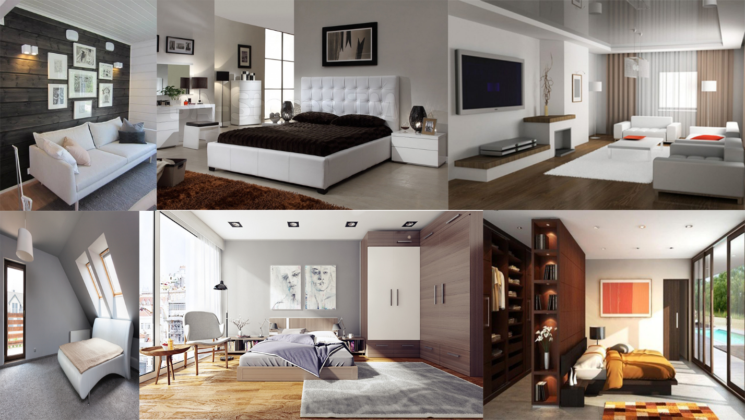

Additional documentation

In this sketch I made a simple initial layout of Kenji’s room which in the end got changed because when I could see the room in 3D I had a better idea of where to place stuff.

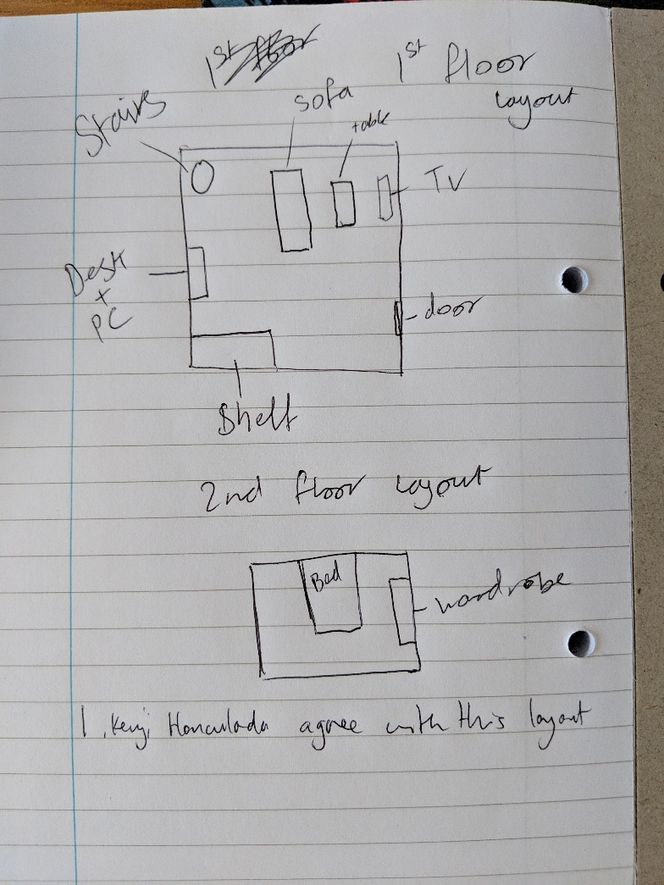

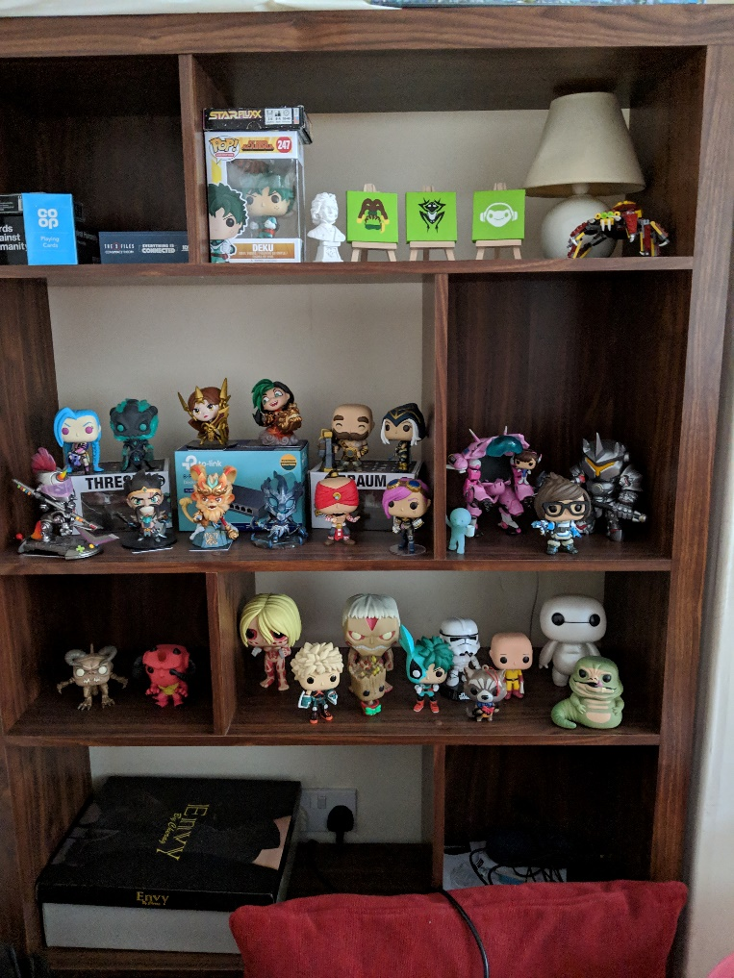

This was the ideal shelf set that Kenji wanted because it allowed for different sections show off different things such as books or figures and it also fit his simplistic look with a wood texture.

Google drive:

<https://drive.google.com/open?id=13-G1NK5ZoJlysOHxyzrVk_mCWQn1KtN0>

**3rd Party assets and creative commons**

Every asset I collected was useable without a licence.

For the door scene I used Yughues Free Metal Materials from the unity asset store - <https://assetstore.unity.com/packages/2d/textures-materials/metals/yughues-free-metal-materials-12949>

For the Room scene I used MEZANIX’s High Quality Realistic Wood Textures – Mega Pack from the unity asset store - <https://assetstore.unity.com/packages/2d/textures-materials/wood/high-quality-realistic-wood-textures-mega-pack-75831>

The sounds I got from freesounds are of course fair use:

Jaraxe – Sci-fi alarm

Dcpoke – birds singing

Primevil-polypod – door-open-close

The piece of music I got was from a royalty free music site - <https://www.bensound.com/>

Happy rock by bensound